FARNCOMBE DAY CENTRE
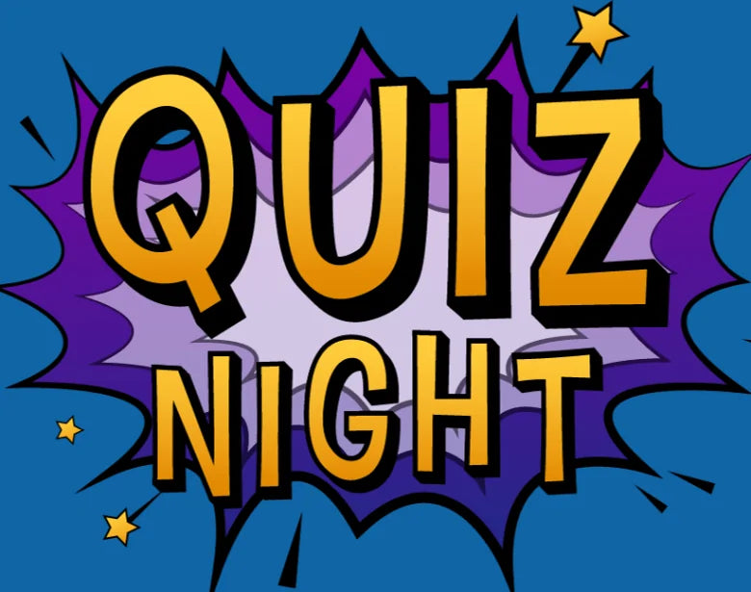

AT
FARNCOMBE DAY CENTRE
ST. JOHNS STREET
ON
FRIDAY 30TH OCTOBER 2026
7.30 pm
TEAMS OF 6/8 PER TABLE
COST £10 PER PERSON
QUIZ MASTER, RAFFLE.
BRING YOUR OWN DRINKS/FOOD
PLEASE PAY WHEN BOOKING TEL: 01483 426685
OR CALL INTO THE OFFICE
NO FOOD PROVIDED

